HANOI UNIVERSITY OF SCIENCE AND TECHNOLOGY

SCHOOL OF INTERNATIONAL EDUCATION

SCIENCE AND TECHNOLOGY MAJOR



**THESIS**

SUBMITTED FOR PARTIAL FULFILLMENT OF

THE REQUIREMENTS FOR THE DEGREE OF

**ENGINEER**

IN

**INFORMATION TECHNOLOGY**

BUILDING A WEBSITE FOR REAL ESTATE EXCHANGE

Author: **Phan Tuan Anh**

Class: **LTU13B**

Supervisor:**Nguyen Thanh Hung**

HANOI, 12/2019

**GRADUATION THESIS DELEGATION SHEET**

**1. Student information:**

Full name: Phan Tuan Anh

Mobile number: 0329709515

Email: anh.pt300696@gmail.com

Class: LTU13B SIE

Hanoi University of Science and Technology

Time: from 01/ 09 /2019 to 24/12/2019

**2. Thesis target:**

* Reduce manual work, administrative procedures in the crowdfunding information by using information technology.

**3. Main tasks of graduation thesis:**

* Learn about .Net framework, Web Language, ect
* Design interface for Crowd-funding website.
* Design database for Crowd-funding website.
* Building website using .Net framework and complete the functions for website.
* Test performance and performance evaluation.

**4. Student commitment:**

I – Phan Tuan Anh - would like to commit that the graduation thesis is my own research under the guidance of Mr. Nguyen Thanh Hung. All the results in the thesis are truthful and I don’t copy from other sources. Any unauthorized copying, violation of training regulations, or fraud, I accept full responsibility.

|  |  |
| --- | --- |
|  | *Hanoi, 24th Dec 2019*  Thesis author  Phan Tuan Anh |

**5. Approval of Lecturer:**

|  |  |
| --- | --- |
|  | *Hanoi, 24th Dec 2018*  Supervisor  Mr. Nguyen Thanh Hung |

# ACKNOWLEDGEMENTS

I would like to express my deepest appreciation to all those who help me the academic guidance that during the time of my studying at the Hanoi University of Science and Technology.

I wish to acknowledge, first and foremost, my supervisor, Mr. Nguyen Thanh Hung- Lecturer of The School of Information and Communication Technology, Hanoi University of Science and Technology, for his guidance, caring and supporting throughout the completion of this thesis.

# ABSTRACT OF THESIS

The information technology industry is a rapidly growing and widely applied science industry. In line with the development trend of media such as newspapers, radio ... Internet usage is becoming more and more popular. Learning, entertainment, business ... are fast, convenient and highly effective. Internet access we have a huge information warehouse serving all needs with just one click.

Recognizing the above problem, we aim to build a website that allows customers to post, sell, rent and search properties according to their needs in the most convenient way. The visual information and images help customers easily compare, choose ... Intermediary brokerage activities in the real estate market are very necessary because real estate is characterized as fixed so it is not Can bring display and specific introduction.

We will cover the managment of information catalogs of real estate as well as contracts for posting and advertising on the website by managing SQL Server database, writing application to communicate user on the website. browse Google Chrom, Coc Coc or Microsoft Edge in ASP.NET language on MVC model.

However, due to the limited time of making the project, the website, despite reflecting the requirements set out, still cannot avoid the limitations, I would like to ask teachers and friends to contribute ideas.

# STRUCTURE OF THESIS

**Chapter I: Introduction**

* Cause and target
* Scope and method

**Chapter II: Theoretical Basis**

* Overview about web
* Introduce about ASP.Net MVC

**Chapter III: System Analysis**

* System user object
* User -case diagram
* Activity diagram
* Sequence diagram

**Chapter IV: System Design**

* Table Design
* Relationship diagram between tables

**Chapter V: Interface and Demo**

* Interface
* Demo

**Chapter VI: Conclustion**

Contents

ACKNOWLEDGEMENTS 3

ABSTRACT OF THESIS 4

STRUCTURE OF THESIS 5

LIST OF FIGURES 7

CHAPTER I: INTRODUCTION 11

1.CAUSES OF THE THESIS 11

1.TARGET OF THE THESIS 12

1.METHOD 12

1.1 Research Method 12

CHAPTER II: THEORETICAL BASIS 14

I1.1 Stratification in Web applications 14

I1. Introducing ASP.Net MVC 15

I1.1. Overview Asp.Net MVC 15

I1.2 History of Asp.Net MVC 17

II1. Who uses the system 18

II1.1. Manager 18

II1.2. Customer 19

II1.3. User 19

II1.4. Member 19

II1.2. Usecase Member registration 21

2.3. Usecase Change Information 21

2.4. Usecase Post News about Real State 21

2.5. Usecase Manage Real Estate Information 21

2.6. Usecase Manage Renting Information 21

2.7. Usecase Manage Messages from Customers 22

2.8. Usecase Contact Company 22

2.9. Usecase Export Invoice 22

2.10. Usecase Manage Employee Information 22

2.11. Usecase Search for services 22

2.12. Usecase Book Service for Members 22

3. The Activity Diagram 23

3.1. Login activity diagram 23

3.2. Sign up activity diagram 24

3.3. Information change activity diagram 25

3.4. Real estate posting activity diagram 26

3.5. Activity diagram contacting the company 27

3.6. Activity diagram of Customer Booking 28

3.7. Activity diagram of the member's Booking 29

4. Sequence Diagram 30

4.1. Sequence diagram of sign up 30

4.2. Sequence diagram log in 30

4.3. Sequence diagram posting real estate news 31

4.4. Sequence management chart for booking 32

4.5. Sequence diagram Employee information management 33

4.6. Sequence diagram of real estate search 34

CHAPTER IV. SYSTEM DESIGN 34

1. Database design 35

1.1. Table design 35

1.2. Relationship diagram between tables 39

CHAPTER V: INTERFACE AND DEMO 39

# 

# LIST OF FIGURES

|  |  |
| --- | --- |
| Figure | Description |
| Figure 1.1 | Web Stratification |
| Figure 1.2 | Web Application Architecture |
| Figure 1.3 | MVC Model |
| Figure 2.0 | Usecase Diagram |
| Figure 3.1 | Login Activity Diagram |
| Figure 3.2 | Sign Up Activity Diagram |
| Figure 3.3 | Information Change Activiti Diagram |
| Figure 3.4 | Real Estate Posting Activity Diagram |
| Figure 3.5 | Contacting Company Activity Diagram |
| Figure 3.6 | Acitivity Diagram of Customer Booking |
| Figure 3.7 | Activity Diagram of Member Booking |
| Figure 4.1 | Sequence Diagram of Sign Up |
| Figure 4.2 | Sequence Diagram of Log In |
| Figure 4.3 | Sequence Diagram posting real estate news |
| Figure 4.4 | Sequence Diagram management chart for booking |
| Figure 4.5 | Sequence diagram employee information management |
| Figure 4.6 | Sequence Diagram of real estate search |
| Figure 5.1 | Database Relationship |
| Figure 5.2 | Home Page |
| Figure 5.3 | Services Page |
| Figure 5.4 | Detail Page |
| Figure 5.5 | Sign Up Page |
| Figure 5.6 | Login Page |
| Figure 5.7 | Contact Company Page |
| Figure 5.8 | Comment Page |
| Figure 5.9 | News Posting Page |
| Figure 5.10 | Real State’s Information Page |
| Figure 5.11 | Booking Page |
| Figure 5.12 | Booking Form Page |
| Figure 5.13 | Admin Login Page |
| Figure 5.14 | Admin Home Page |
| Figure 5.15 | Real State Management Page |
| Figure 5.16 | Real State Detail Page |
| Figure 5.17 | Employee Management Page |
| Figure 5.18 | Member Management Page |
| Figure 5.19 | Customer Management Page |
| Figure 5.20 | Comment Management Page |
| Figure 5.21 | Renting Management Page |
| Figure 5.22 | Invoice Management Page |
| Figure 5.23 | Invoice’s checking info Page |

# CHAPTER I: INTRODUCTION

## 1.CAUSES OF THE THESIS

The rapid development of information technology in general and the Internet in particular has brought a lot of changes in business methods as well as consumer habits. By the Internet, we have done a lot of work much faster and cost much less than the traditional way. With simple actions on computers connected to the Internet, you will have what you need without having to spend a lot of time. We just need to go to the e-commerce service pages, follow the instructions and click on what we need, the service will be delivered to our door.

Nowadays, in addition to advertising on mass media such as television, newspapers and radio, Internet advertising has become popular. Data is updated quickly, stored for a long time and easily searched is the strength of the Internet. E-commerce is no stranger to us all. The purchase and sale transactions are done online with encouraging advantages. However, for common goods, the display and introduction are diverse and relatively easy to the user. But the type of real estate (Real Estate) has its own characteristics so I want to build a website for users to post ads for their properties in the most convenient way. Customers will not be charged brokerage services when selling, buying or renting a house or land as in real estate centers. The more detailed the customer information and the more images will make the searcher accessible, with a more specific look.

In addition, in the current open economic context, real estate transactions in Vietnam are trending to develop the network, so it is necessary to build a direct real estate information trading website. real for the real estate market. The real estate transaction website provides accurate information, pricing and area of the projects. Can promote to help sellers and buyers easily access information and satisfy transaction needs in the shortest time. At the same time, customers can also give feedback on the quality of the service, thereby helping other customers get reference information to decide for their own choice.

Currently, many apartments, resorts, business premises, offices, houses, villas, .. are growing more and more. Along with that, the demand for searching in a certain area to rent, buy, or rent short-term tourism is also increasing. Therefore "JM Real Estate Website" was born to help people easily find apartments, real estate, .. according to their needs in the easiest and most convenient way.

## 1.TARGET OF THE THESIS

The goal of this project is to build a website with an intuitive interface, easy to use to search, post information and book. Users can search with real estate information along with details associated with it. It is also possible to advertise and evaluate real estate.

## 1.METHOD

### 1.1 Research Method

* Survey and consult available real estate websites
* Consult the user

**1.2 Engine Used**

* Use C# language based on ASP.Net with MVC model, HTML, CSS, JS to design interface and fuctions
* Use Microsoft Visual Studio 2019 to asist to write code.
* Use Microsoft SQL 2014 to store database.

#### I.4.Scope of the Thesis

Website was implemented in area of Hanoi.

**I.5. Describe the Operational Activities of the System**

**I.5.1. Agent**

* Customer:
  + View information
  + Sign up
  + Contact to company
* Member:
  + Rent the property
  + Post news
* Admin:
  + Manage system
  + Manage renting
  + Export the bill

**I.5.2. Business operation process:**

User objects include:

* The party wants to sell or lease
* The party wants to buy or rent
* Admin

Operation process of the above subjects is presented as follows:

* Party wants to sell or lease: When wishing to sell or rent real estate, the property owner will create an account and log in to the website to be able to post information. Within 7 days after the news is posted, the property owner must pay the fee as agreed with the company in the form of payment. Posting service fee will be calculated from the time of posting. If the property owner does not contact the payment after 7 days, the company will delete without notice. Within 7 days the news will be posted for free.
* Party wants to buy or hire: When customers want to buy, hire a house or land, customers will go to the company's website to search for information about real estate according to the list for selling, or for hire. Then the customer at the account and register to hire / buy that property. If there is no demand for hireing / buying, customers can register for an account and post information. The company will not charge this service fee. Postings will be deleted after 30 days.
* Admin: Manage real estate information, customer information, accounts, employee information, posting information, deleting postings. And invoicing when successful transactions for customers.

# CHAPTER II: THEORETICAL BASIS

**I1.Overview of web applications:**

Web applications are programs that execute on the web server (Web server) and access and interact with the user via a web browser. This concept is widely accepted by users, but nowadays IT develops strongly, a series of technology platforms are born, web applications may not need to interact or execute on the server. web, meaning this web application runs purely on a web browser. That means web applications without an Internet connection will still be able to run.

Web applications that allow users to share and access information via the Internet. Programmers can create web applications for commercial purposes such as online sales websites ...

Web applications can be viewed in many different directions: The views of application developers, often dividing the web application into many different layers, each of which takes on a number of logical tasks of application. Application development perspectives, often dividing the application into different physical components, these physical components are installed at different computers (network nodes) in the system.

### I1.1 Stratification in Web applications

This approach separates the application into logical components. This is the view of application developers, usually web applications are divided into the following stratification:

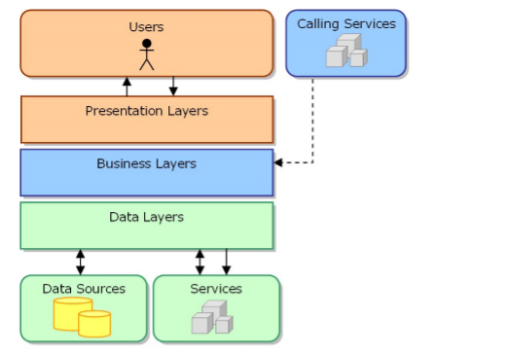

Figure 1.1. Web Stratification

* Presentation Layer (Presentation Layer): The interface component, is the form of the program to interact with the user.
* Business Process Layer (Business Logic Layer): Process the operations of the program such as computation, processing and data integrity.
* Data layer (Data Layer): Store and process information related to the data of the program. Usually, this layer includes the communication layer with the Database Management System and Database Management System.

**I1.2 Web Application Architecture**

Following this approach, divide the application into physical components. This is the view of application deployment, web applications are often divided as follows:

Single-Tier: All layers of the application are integrated and installed on one computer.

Two-Tier: According to this architecture all 3 layers are installed on 2 levels: client and server, demonstration layer is installed on client, 2 floors (Business layer and data layer) are installed on server.

Three-Tier: According to this architecture, three layers (layers) will be installed at different computers, each layer will communicate with other layers to meet the requirements of information exchange between them through mechanisms (Request / Response).

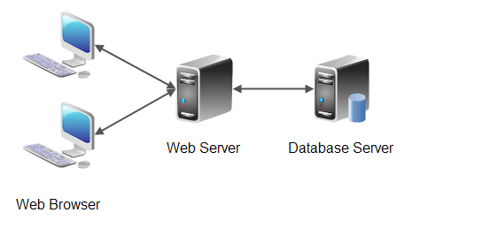

Figure 1.2. Web Application Achitecture

## I1. Introducing ASP.Net MVC

### I1.1. Overview Asp.Net MVC

Asp.Net MVC is a framework that uses .Net Framework for developing dynamic web applications, before Asp.Net MVC was born, programmers used Asp.Net Web Form technology on the .Net Framework platform to develop Dynamic Web application development.  
Asp.Net MVC is based on the standard MVC design pattern, allowing users to develop software applications. MVC is the name of an application development pattern, this method divides an application into three components to install, each component plays a different role and affects each other, that is models, views, and controllers. The following figure depicts the MVC design pattern.

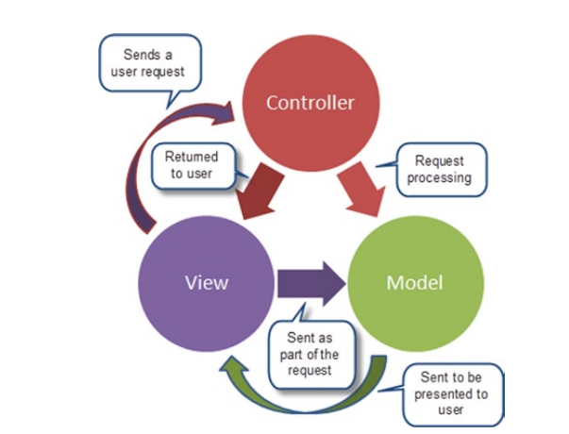

Figure 1.3. MVC Model

Main features of Model, View and Controller are in the standard MVC design pattern.

**Models: Models** objects are part of the application, which establishes the logic of the application's data section. Typically, model objects retrieve and store model state in the database. For example, an Employee object will retrieve data from a database, manipulate the data, and will update the data back to the Eployees table in SQL Server. In small applications, the model is often just a concept to distinguish it from being actually installed, for example, if the application only reads data from the database and sends it to the view, the application does not need to be cascaded. model and related classes. In this case, the data is taken as a model object (rather than the model tier ).

**Views:** View is the component used to display the user interface (UI). Typically, views are created based on model data information. For example, the view used to update the Employees table will display text boxes, drop-down lists, and check boxes based on the current state of an Employee object.

**Controllers:** Controllers are components used to manage user interaction, work with the model, and select views to display the user interface. In an MVC application, the view is only used to display information, the controller is responsible for managing and responding to user input and interaction with the user. For example, the controller will handle the query data (query-string values) and send those values to the model, the model will retrieve data from the database thanks to these values.

The benefits of web applications are based on the MVC model

* Easily manage complexity of applications by dividing applications into three parts: model, view, controller
* It does not use view state or server-based forms. This is good for programmers who want to manage all aspects of an application.
* It uses a Front Controller pattern, which helps manage requests (requests) only through a Controller. Thanks to this you can design a routing management infrastructure.
* Better support for test driven application development model
* It supports applications that are built by teams of developers and designers who manage the features of the application.

### I1.2 History of Asp.Net MVC

* Asp.Net 1.0: The first version was released in March 2009 on the .NET Framework 3.5 Visual Studio 2008 suite.
* Asp.Net 2.0: This version was released in March 2010 on the .Net Framework 3.5 and the .Net Framework 4.0 from Visual Studio 2010.
* Asp.Net MVC 3: This version was released in January 2011 on the .Net Framework 4.0 platform .
* Asp.Net 4.0: This version was released in August 2012 on the platform .Net Framework 4.0 and .Net Framework 4.5 on Visual Studio 2010 SP1 and Visual Studio 2012.
* Asp.Net MVC 5: This version was released in October 2013 on the platform .Net Framework 4.5 and .Net Framework 4.5.1 on Visual Studio 2013 version.

**CHAPTER III: SYSTEM ANALYSIS**

## 1. Who uses the system

This Real Estate Website works primarily for three main subjects: Administrators, Customers, Sales Staff.

### 1.1. Manager

- The administrator of the website has the highest right, holds all the rights in the website

- Can set the rights of all members to use in the site

- Real estate information management

- Manage customer and member information

- Employee management

- Manage reservation information from customers

- Allowed to view and update:

+ Handling hire / purchase orders

+ View customer information

+ Browse posting news

+ Transaction information (Invoice)

+ Services - Customers

+ Issue invoices

- Search and advice

+ Search for requested service information from customers

+ Send feedback to customers

### 1.2. Customer

- Search for services according to your needs

- Register to become a Member

- Contact the company for advice

- Real estate reviews and comments

- Booking of real estate rent

### 1.3. User

- Member registration

- Login

- Change password

### 1.4. Member

- Post real estate news

- Login to post information

- View real estate information

- Booking of real estate rent

- Change password , update personal information

- Manage the real estate information posted

**2. Usecase Description:**

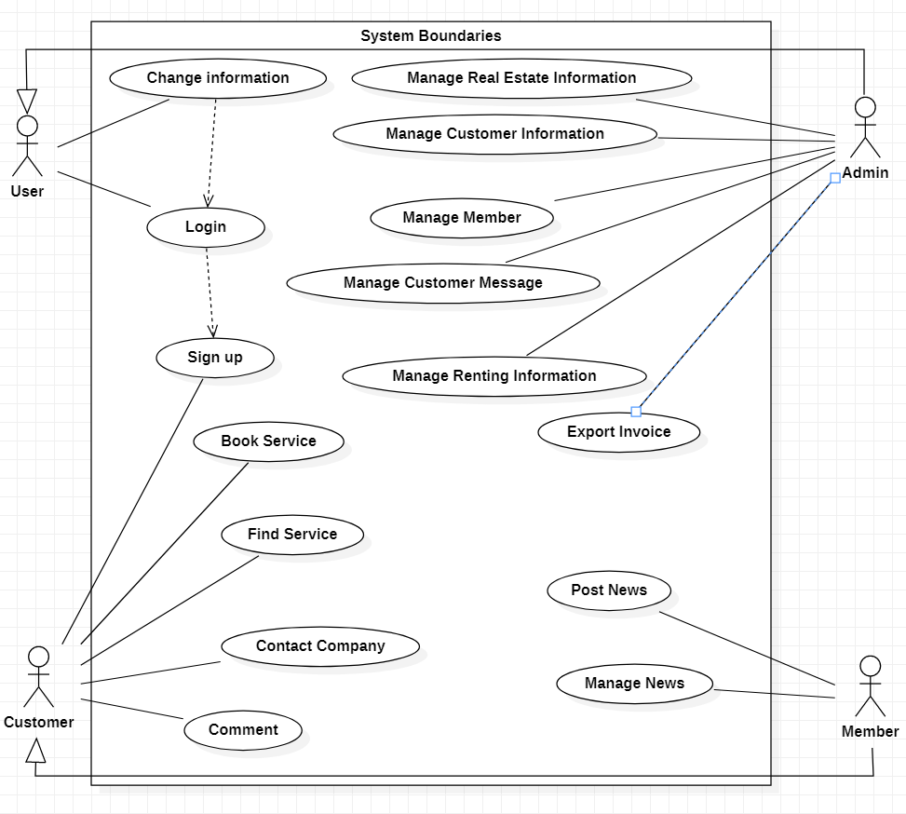

Figure 2.0 Usecase Diagram

**2.1. Usecase Login:**

* Brief description:This Usecase allows customers, members, and administrators to log in to the system
* Actor: Customer, T member, A dmin
* Prerequisite: The customer, member or admin uses the Internet to access the system's website and has an account in the system.

### 2.2. Usecase Member registration

* Brief Description: This Usecase allows customers to register for an account if they want to post property or place a reservation without an existing account in the system.
* Actor: The customer
* Prerequisite: Customers use the Internet to access the system website and the account they want to create is not in the system.

### 2.3. Usecase Change Information

* Brief Description: This Usecase allows users to change personal information already in the system
* Actor: User
* Prerequisite: The user uses the Internet to access the system's website and the account you want to change information already in the system

### 2.4. Usecase Post News about Real State

* Brief Description: Usecase allows customers, real estate owners to post real estate news on the website
* Actor: Member
* Prerequisite: Actors use the Internet to access the system website and must log into the system.

### 2.5. Usecase Manage Real Estate Information

* Brief Description: Usecase allows the Admin to add, edit and delete real estate information such as property name, address, region, type of real estate, etc.
* Actor: Admin
* Prerequisite: Actors use the Internet to access the system website and must log into the system. In addition, the login account must be granted Admin rights.

### 2.6. Usecase Manage Renting Information

* Brief Description: Usecase allows the Admin to view member reservation information
* Actor: Admin
* Prerequisite: Actors use the Internet to access the system website and must log into the system.

### 2.7. Usecase Manage Messages from Customers

* Brief Description: Usecase allows the Admin to view messages sent from customers. Admin will view and respond to those contact messages via email.
* Actor: Admin
* Prerequisite: Actors use the Internet to access the system website and must log into the system.

### 2.8. Usecase Contact Company

* Brief Description: Usecase allows customers to send messages to the company about their needs. The company's admin will then view and respond via email.
* Actor: Kh evil H alk g
* Prerequisite: An email inbox is required to receive feedback from the company.

### 2.9. Usecase Export Invoice

* Brief Description: Usecase allows the Admin to export invoices after successful transactions between the customer and the lessor / seller.
* Actor: Admin
* Prerequisite: The rental order has been invoiced. Actors use the Internet to access the system website and must log into the system.

### 2.10. Usecase Manage Employee Information

* Brief Description: Usecase allows the Admin to add, edit, and delete employee information
* Actor: Admin
* Prerequisite: Actors use the Internet to access the system website and must log into the system.

### 2.11. Usecase Search for services

* Brief Description: Usecase allows Customers - Members to search properties by keyword they want.
* Actor: Customer, Member
* Prerequisite: Actors use the Internet to access the system website .

### 2.12. Usecase Book Service for Members

* Brief Description: Usecase allows Members to book a service that suits their needs .
* Actor: Members
* Prerequisite: Actor uses the Internet to access the system's website and then successfully logs in to the system.

## 3. The Activity Diagram

### 3.1. Login activity diagram

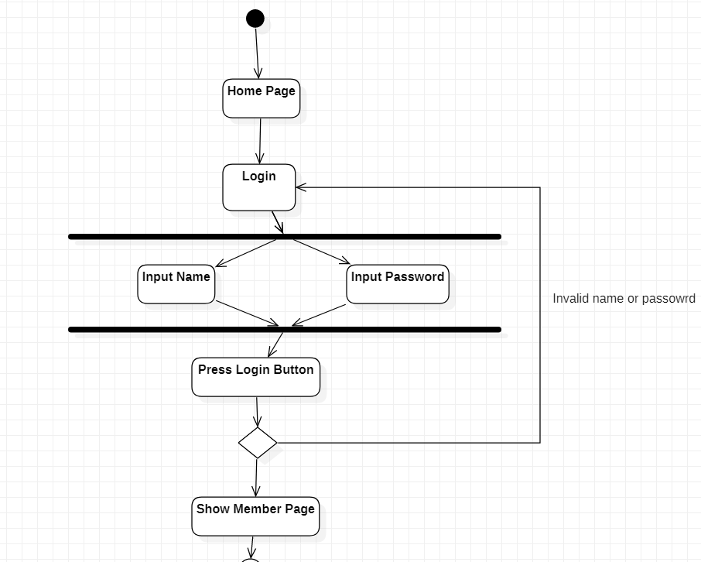

Figure 3.1. Login Activity Diagram

### 3.2. Sign up activity diagram

s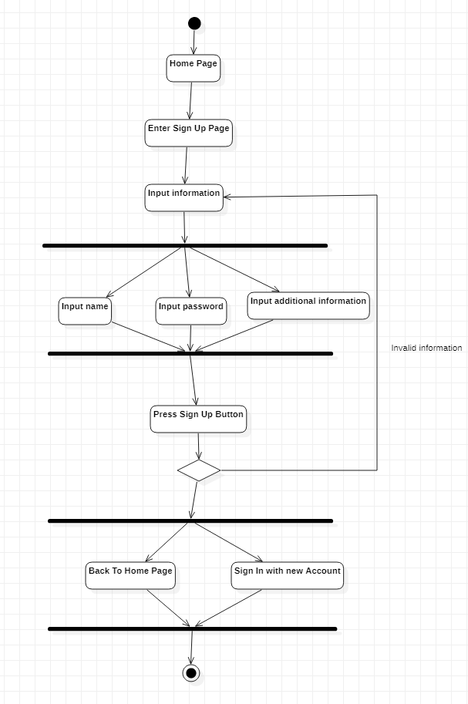

Figure 3.2. Sign Up Activity Diagram

### 3.3. Information change activity diagram

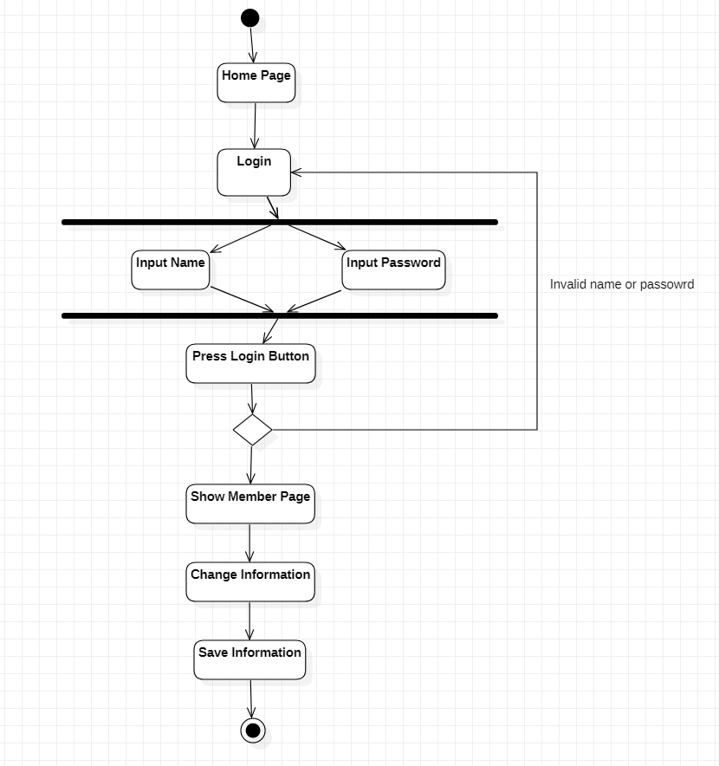

Figure 3.3 Information Change Activity Diagram

### 3.4. Real estate posting activity diagram

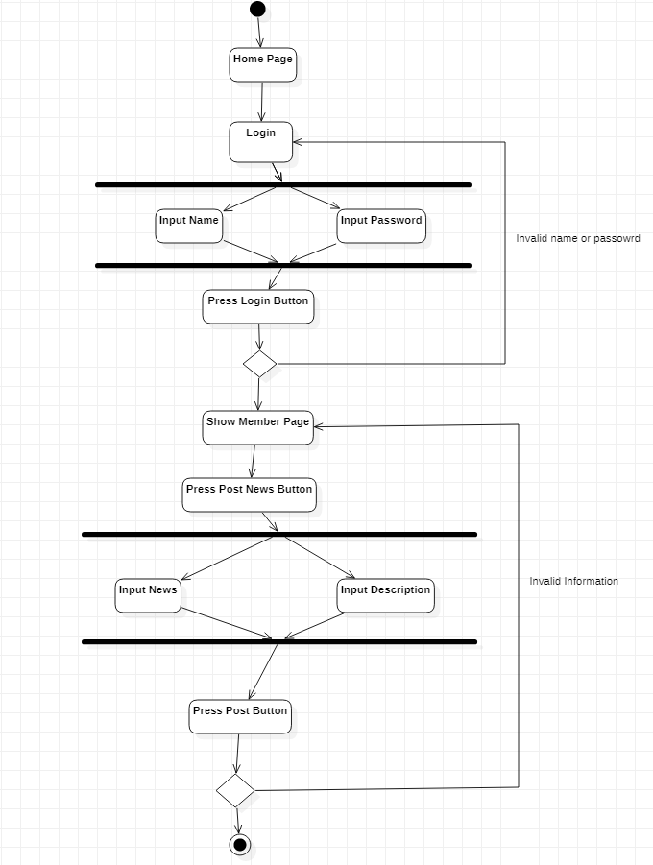

Figure 3.4. Real Estate Posting Activity Diagram

### 3.5. Activity diagram contacting the company

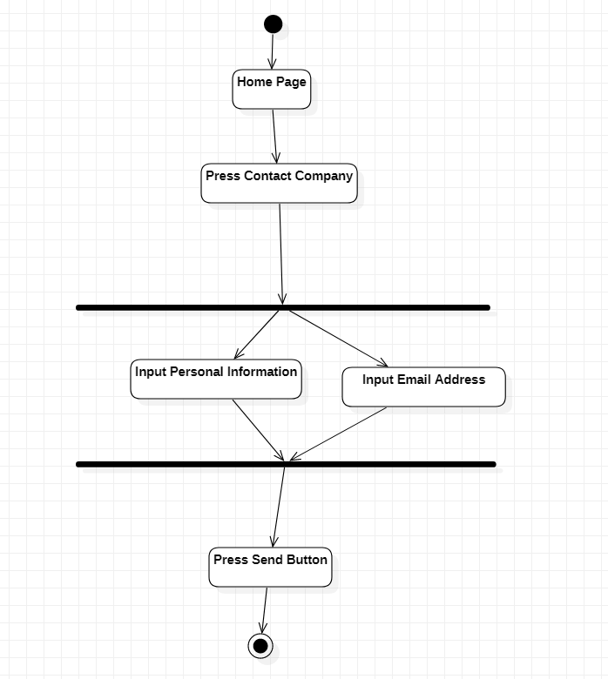

Figure 3.5. Contacting Company Activity Diagram

### 3.6. Activity diagram of Customer Booking

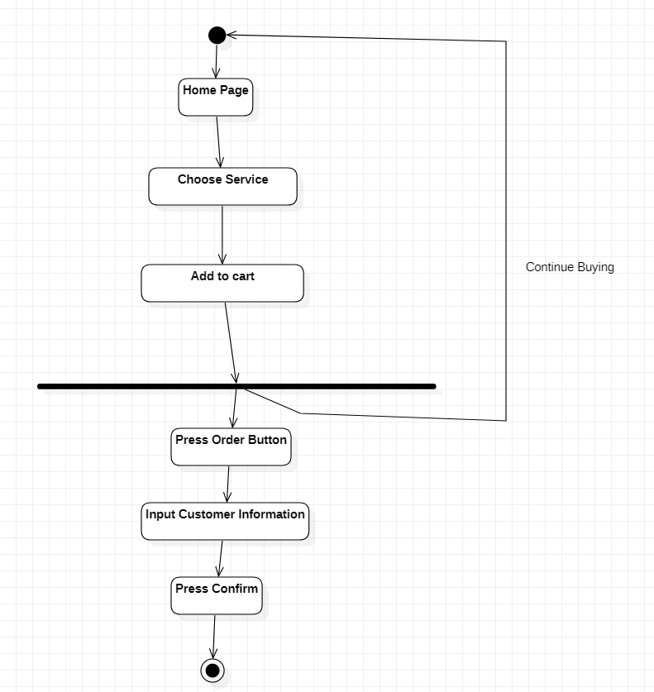

Figure 3.6. Acitivity Diagram of Customer Booking

### 3.7. Activity diagram of the member's Booking

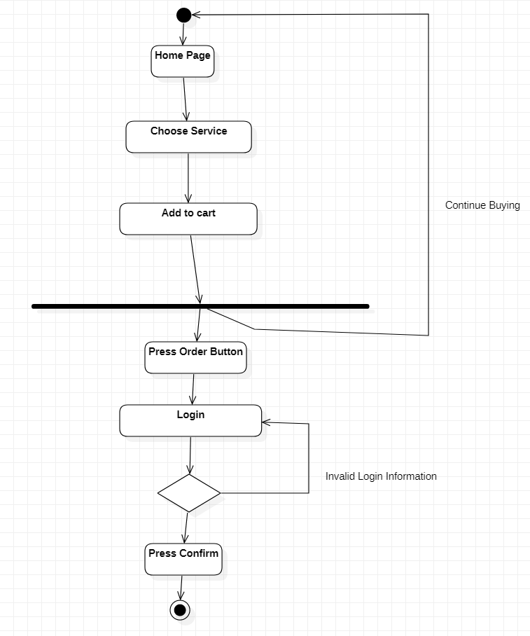

Figure 3.7. Activity Diagram of Member Booking

## 4. Sequence Diagram

### 4.1. Sequence diagram of sign up

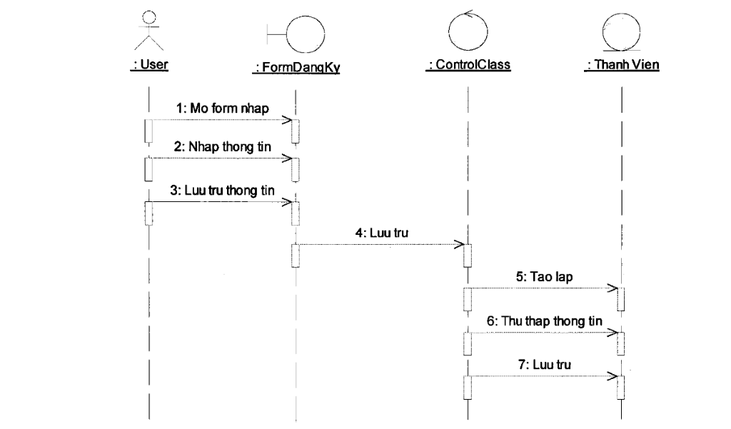

Figure 4.1. Sequence Diagram of Sign Up

### 4.2. Sequence diagram log in

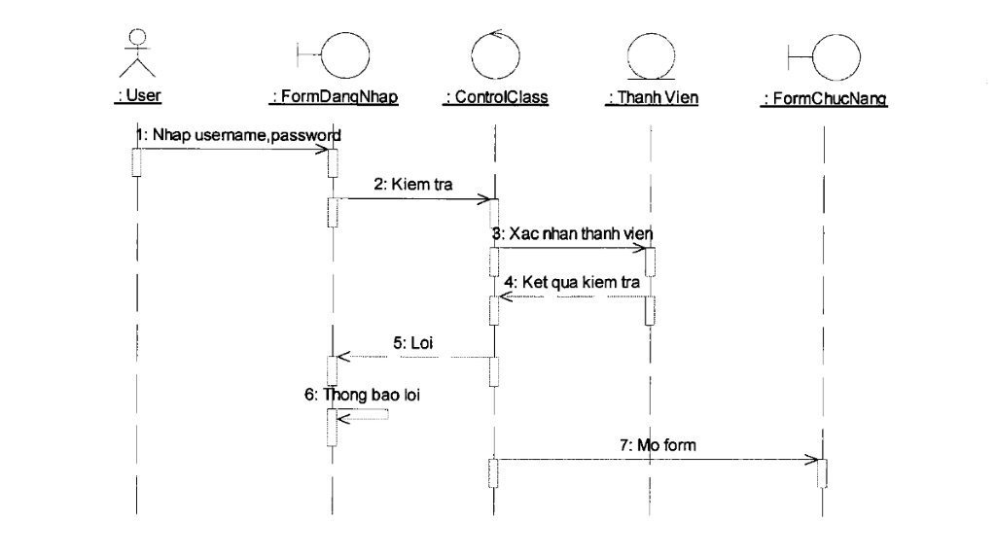

Figure 4.2. Sequence Diagram of Log In

### 4.3. Sequence diagram posting real estate news

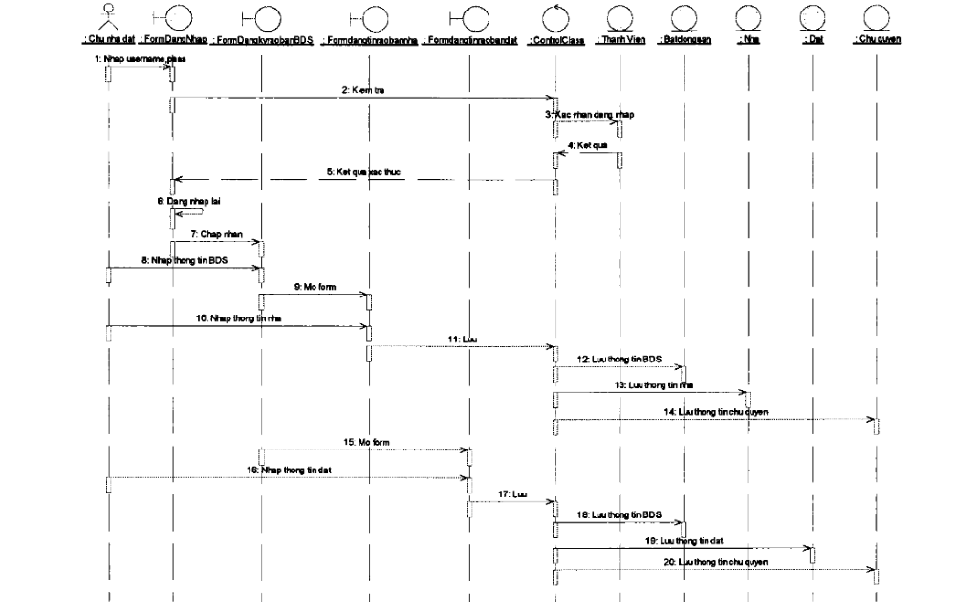

Figure 4.3. Sequence Diagram posting real estate news

### 4.4. Sequence management chart for booking



Figure 4.4. Sequence Diagram management chart for booking

### 4.5. Sequence diagram Employee information management

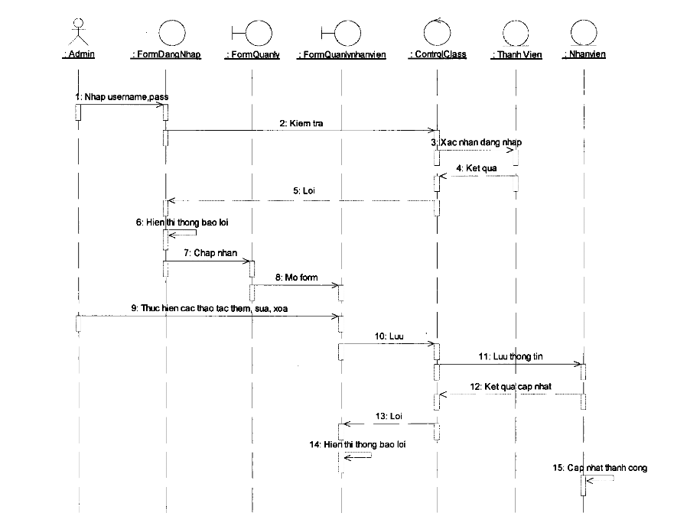

Figure 4.5. Sequence diagram employee information management

### 4.6. Sequence diagram of real estate search

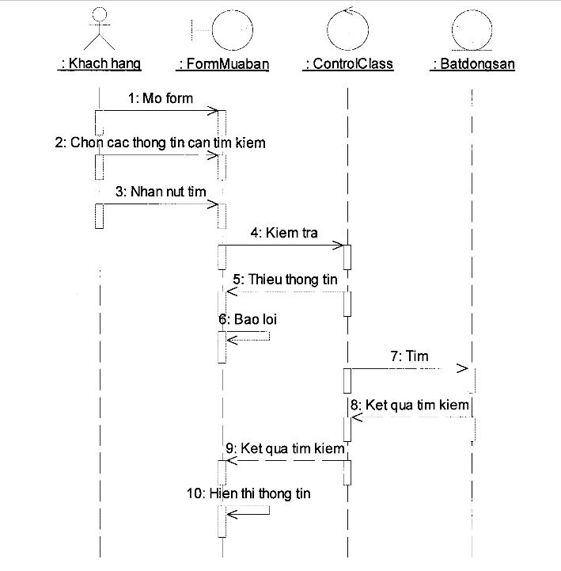

Figure 4.6. Sequence Diagram of real estate search

# CHAPTER IV. SYSTEM DESIGN

## 1. Database design

### 1.1. Table design

1.1.1. Permission Table

|  |  |  |  |  |
| --- | --- | --- | --- | --- |
| No. | Column name | Describe | Datatypes | Note |
| first | MaPQ | Authorized Code | int | Main courses |
| 2 | TenPQ | Authorized Name | nvarchar (10) |  |

1.1.2. Management Board

|  |  |  |  |  |
| --- | --- | --- | --- | --- |
| No. | Column name | Describe | Datatypes | Note |
| first | User Name | account name | varchar (50) | Main courses |
| 2 | Pw | password | varchar (50) |  |
| 3 | MaPQ | Authorization Code | int | Foreign key |

1.1.3. Employee Table

|  |  |  |  |  |
| --- | --- | --- | --- | --- |
| No. | Column name | Describe | Datatypes | Note |
| first | MaNV | Employee Code | i nt | Main courses |
| 2 | HoTenNV | password | n varchar (50) |  |
| 3 | ChucVu | Position | nvarchar (50) |  |
| 4 | Phone | Authorization Code | nvarchar (12) |  |
| 5 | GioiTinh | Sex | nvarchar (6) |  |
| 6 | Address | Address | nvarchar (50) |  |
| 7 | Email | Email | nvarchar (50) |  |
| 8 | UserName | Account name | nvarchar (50) | Foreign key |
| 9 | Facebook | Social Network | nvarchar (255) |  |
| ten | Googleplus | Social Network | nvarchar (255) |  |
| 11 | Twitter | Social Network | nvarchar (255) |  |
| twelfth | Instagram | Social Network | nvarchar (255) |  |

1.1.4. Customer Table

|  |  |  |  |  |
| --- | --- | --- | --- | --- |
| No. | Column name | Describe | Datatypes | Note |
| first | MaKH | Customer's code | int (50) | Main courses |
| 2 | HoTenKH | customer's full name | nvarchar (50) |  |
| 3 | Phone | Phone | char (12) |  |
| 4 | Address | Address | nvarchar (50) |  |
| 5 | Email | Email | nvarchar (50) |  |

1.1.5. Member Board

|  |  |  |  |  |
| --- | --- | --- | --- | --- |
| No. | Column name | Describe | Datatypes | Note |
| first | MaTV | Member ID | int | Main courses |
| 2 | UserName | account name | nvarchar (50) |  |
| 3 | HoTen | Member's name | nvarchar (50) |  |
| 4 | Phone | Phone number | nvarchar (12) |  |
| 5 | GioiTinh | Sex | nvarchar (6) |  |
| 6 | Address | Address | nvarchar (50) |  |
| 7 | Email | Email | nvarchar (50) |  |
| 8 | NgayDK | Registration Date | date |  |

1.1.6. Table Of Real Estate Types

|  |  |  |  |  |
| --- | --- | --- | --- | --- |
| No. | Column name | Describe | Datatypes | Note |
| first | MaLoaiBDS | Property Type Code | int | Main courses |
| 2 | TenLoaiBDS | Name Type Real Estate | nvarchar (50) |  |

1.1.7. Group Table Type

|  |  |  |  |  |
| --- | --- | --- | --- | --- |
| No. | Column name | Describe | Datatypes | Note |
| first | MaNhom | Real Estate Group Code | int | Main courses |
| 2 | TenNhom | Real Estate Group Name | nvarchar (50) |  |

1.1.8. Real Estate Table

|  |  |  |  |  |
| --- | --- | --- | --- | --- |
| No. | Column name | Describe | Datatypes | Note |
| first | MaBDS | Property Code | int | Main courses |
| 2 | TenBDS | Real Estate Name | nvarchar (50) |  |
| 3 | MaNhom | Group Code | int | Foreign key |
| 4 | MaLoaiBDS | Property Type Code | int | Foreign key |
| 5 | UserName | account name | varchar (50) | Foreign key |
| 6 | Date | Date Submitted | date |  |
| 7 | Duyet | Browser | Int |  |

1.1.9. Table Of Real Estate Details

|  |  |  |  |  |
| --- | --- | --- | --- | --- |
| No. | Column name | Describe | Datatypes | Note |
| first | No. | Numerical order | int | Main courses |
| 2 | MaBDS | Property Code | int | Foreign key |
| 3 | Gia | Price | decimal (18.2) |  |
| 4 | DienTich | Acreage | nvarchar (50) |  |
| 5 | DiaChiBDS | Real Estate Address | nvarchar (50) |  |
| 6 | Mota | Describe | nvarchar (1000) |  |
| 7 | KhuVuc | Area | nvarchar (50) |  |
| 8 | Image | Image | nvarchar (255) |  |
| 9 | PhongTam | Bathroom | Int |  |
| ten | PhongNgu | Bedroom | Int |  |
| 11 | Paking | Parking | varchar (10) |  |

1.1.10. Rent Management Table

|  |  |  |  |  |
| --- | --- | --- | --- | --- |
| No. | Column name | Describe | Datatypes | Note |
| first | MaDat | Rental Code | i nt | Main courses |
| 2 | MaKH | Customer's code | i nt | Foreign key |
| 3 | MaBDS | Property code | i nt | Foreign key |
| 4 | Right | Date of booking | d ate |  |
| 5 | GhiChu | Note | n varchar (50) |  |
| 6 | ThanhToan | Pay | int |  |

1.1.11. Customer Booking Management Table

|  |  |  |  |  |
| --- | --- | --- | --- | --- |
| No. | Column name | Describe | Datatypes | Note |
| first | MaDat | Rental Code | int | Main courses |
| 2 | MaKH | Customer's code | int | Foreign key |
| 3 | MaBDS | Property code | int | Foreign key |
| 4 | Date | Date of booking | date |  |
| 5 | GhiChu | Note | nvarchar (50) |  |
| 6 | ThanhToan | Pay | int |  |

1.1.12. Billboard

|  |  |  |  |  |
| --- | --- | --- | --- | --- |
| No. | Column name | Describe | Datatypes | Note |
| first | MaHD | Code Bill | int | Main courses |
| 2 | MaKH | Customer's code | int | Foreign key |
| 3 | MaNV | Employee code | int | Foreign key |
| 4 | MaBDS | Property code | int | Foreign key |
| 5 | TongTien | Total money | decimal (18.2) |  |
| 6 | NgayThanhToan | Date of payment | date |  |

1.1.13. Comment Board

|  |  |  |  |  |
| --- | --- | --- | --- | --- |
| No. | Column name | Describe | Datatypes | Note |
| first | MaBL | Comment code | int | Main courses |
| 2 | TenBL | Comment name | nvarchar (50) |  |
| 3 | NoiDungBL | Comment content | nvarchar (1000) |  |
| 4 | MaBDS | Property code | int | Foreign key |
| 5 | NgayBL | Date of comment | date |  |
| 6 | Duyet | Browser | int |  |

1.1.14. Contact Table

|  |  |  |  |  |
| --- | --- | --- | --- | --- |
| No. | Column name | Describe | Datatypes | Note |
| first | MaLienHe | Contact code | int | Main courses |
| 2 | HoTen | Name of contact person | nvarchar ( 100 ) |  |
| 3 | Email | Email | nvarchar (100) |  |
| 4 | Title | Title | nvarchar (255) |  |
| 5 | LoiNhan | Message | nvarchar (1000) |  |

### 1.2. Relationship diagram between tables

Figure 5.1. Database Relationship

# CHAPTER V: INTERFACE AND DEMO

**V.1.User Interface**

**1.1 Index**

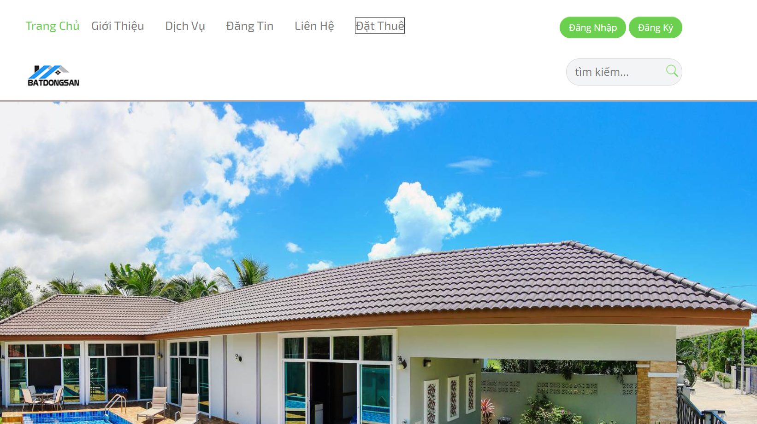

Figure 5.2. Home Page

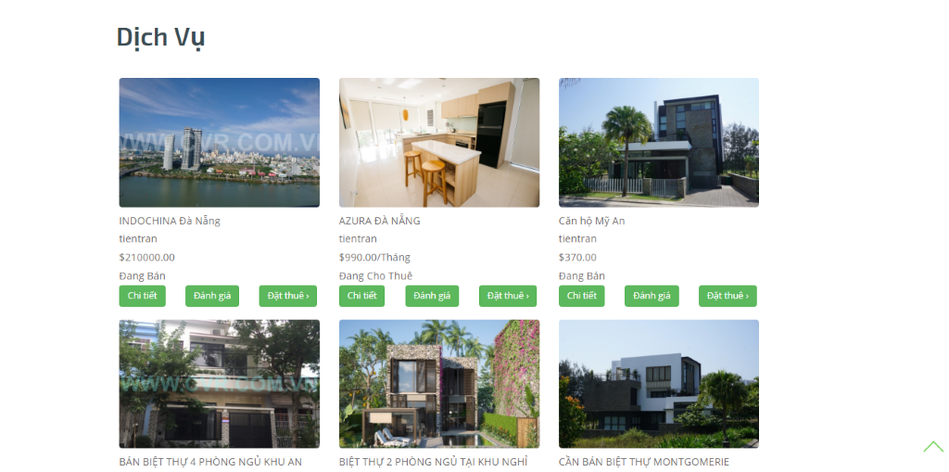

Figure 5.3. Services Page

**1.2. Real State’s Detail Page**

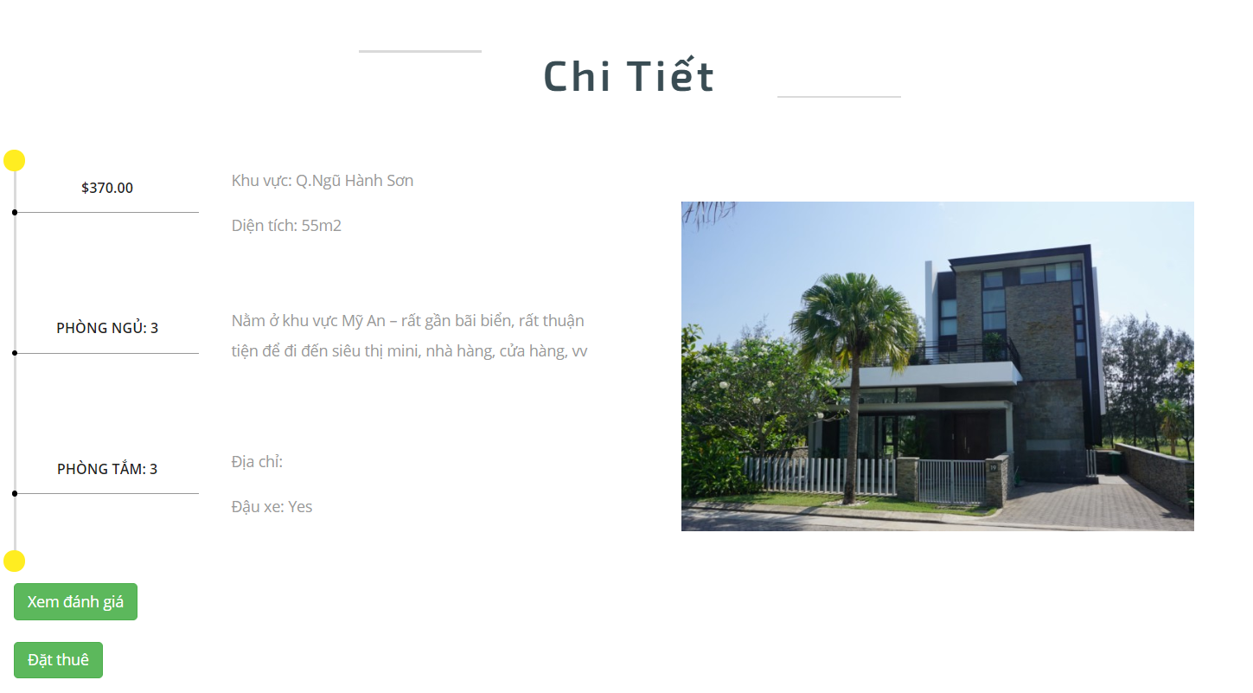

Figure 5.4. Detail Page

**1.3. Sign Up Page**

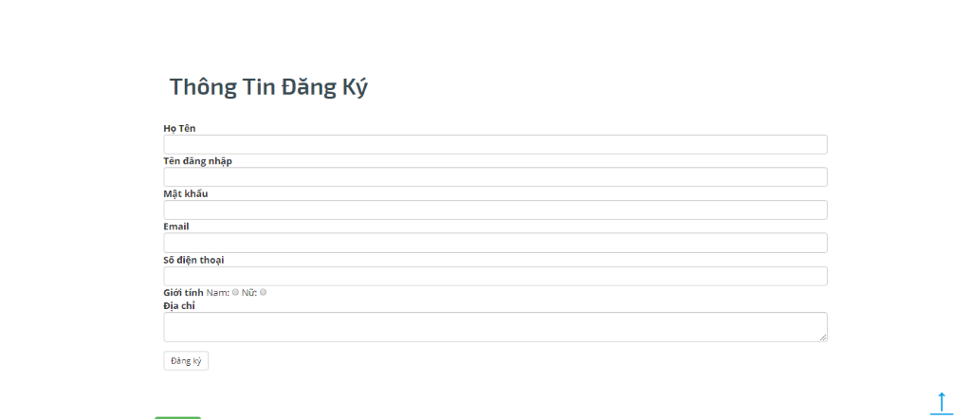

Figure 5.5. Sign Up Page

**1.4. Login Page**

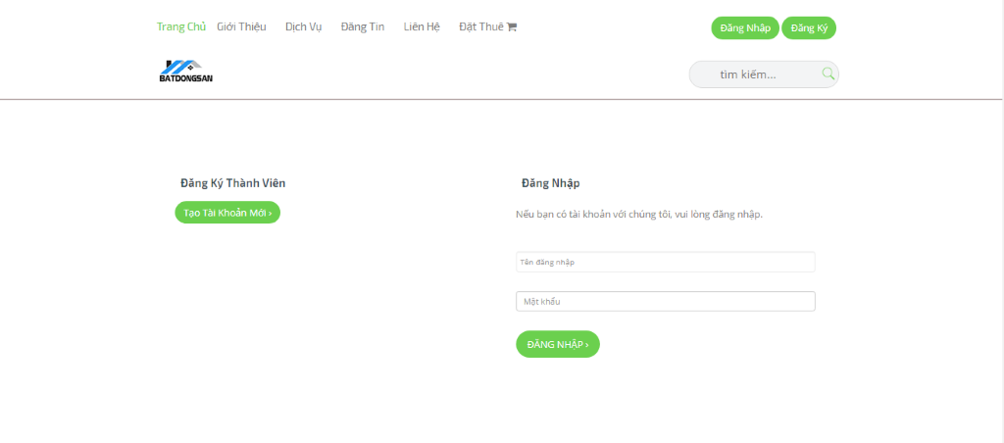

Figure 5.6 Login Page

**1.5. Contact Company Page**

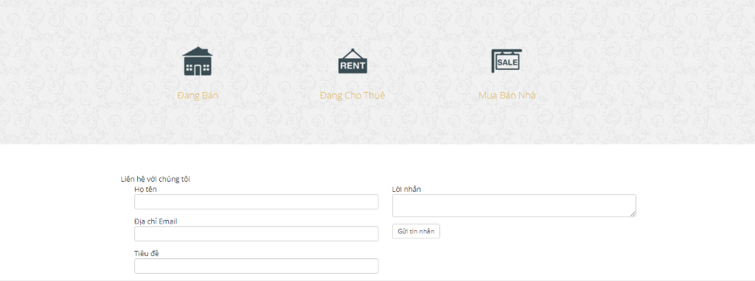

Figure 5.7. Contact Company Page

**1.6. Comment Page**

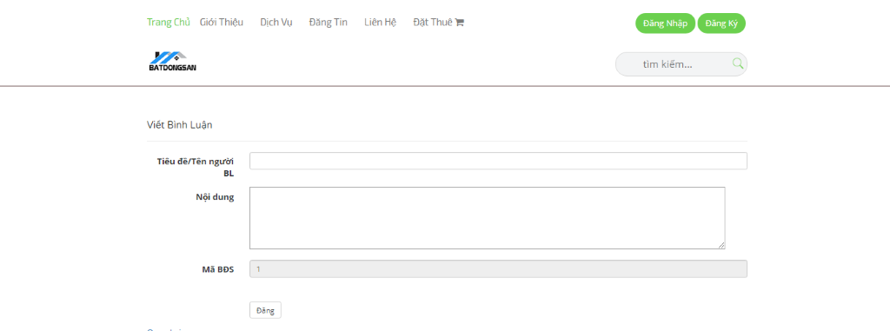

Figure 5.8. Comment Page

**1.7. News Posting Page**

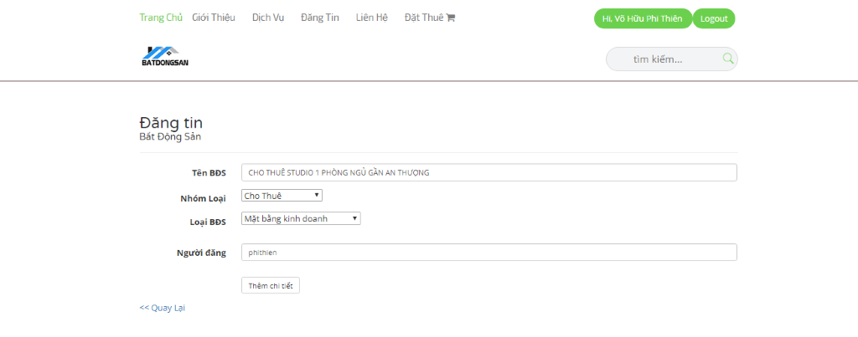

Figure 5.9. News Posting Page

**1.8. Adding Real State’s Information Page**

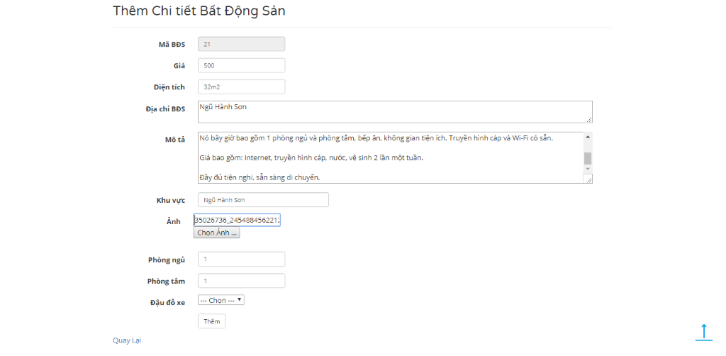

Figure 5.10. Real State’s Information Page

**1.9. Booking Page**

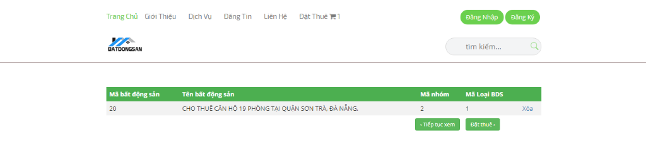

Figure 5.11. Booking Page

**1.10. Booking Form Page**

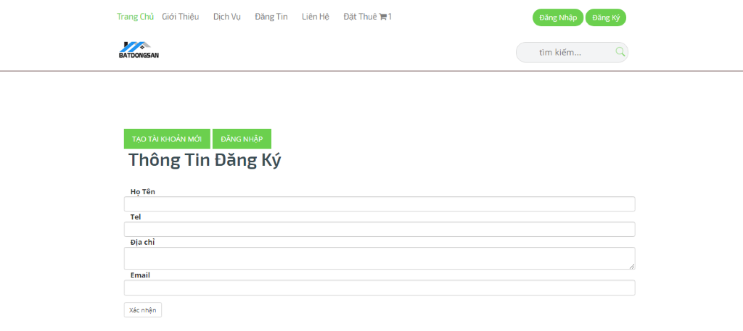

Figure 5.12. Booking Form Page

1. **Admin Interface**

**2.1. Login Page**

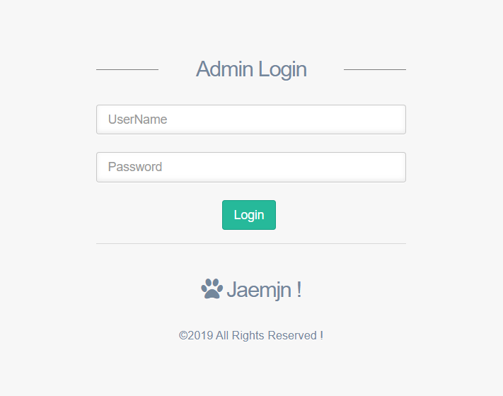

Figure 5.13 Admin Login Page

**2.2. Admin Home Page**

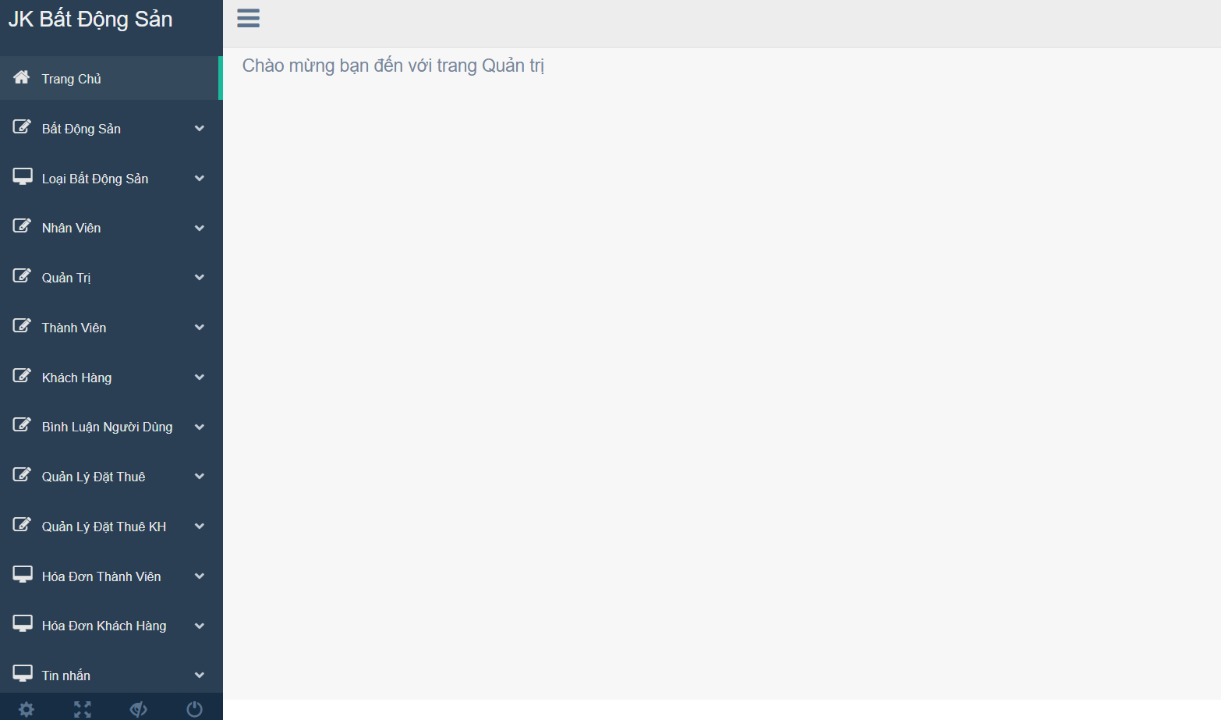

Figure 5.14. Admin Home Page

**2.3. Real Estate Management Page**

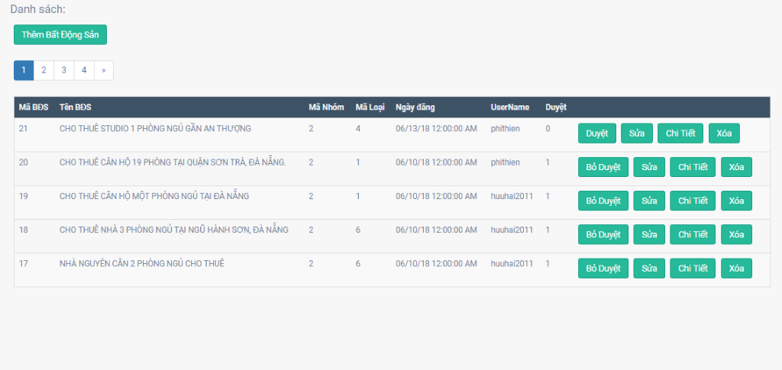

Figure 5.15. Real State Management Page

**2.4. Real Estate Detail Page**

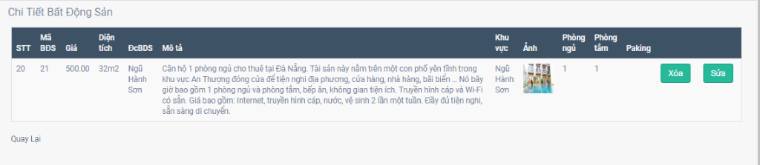

Figure 5.16. Real State Detail Page

**2.5. Employee Management Page**

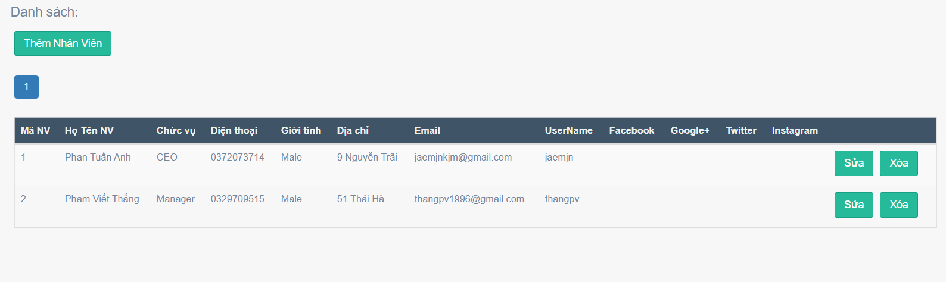

Figure 5.17. Employee Management Page

**2.6. Member Management Page**

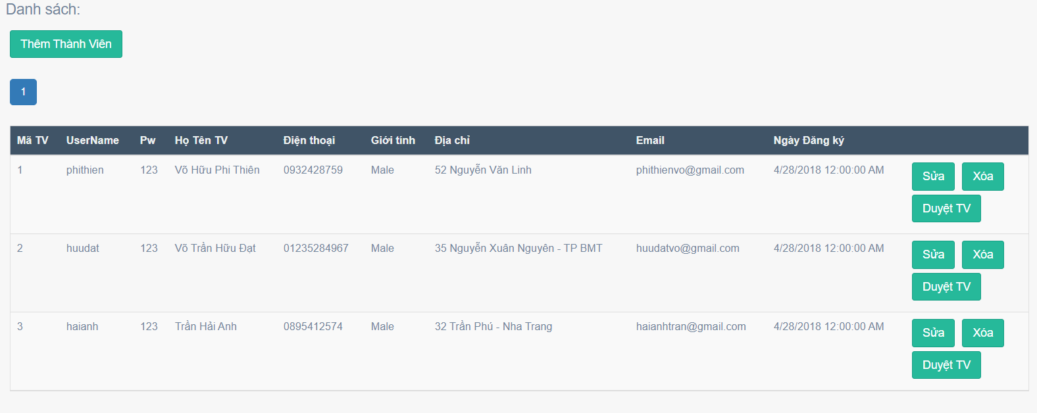

Figure 5.18 Member Management Page

**2.7. Customer Management Page**

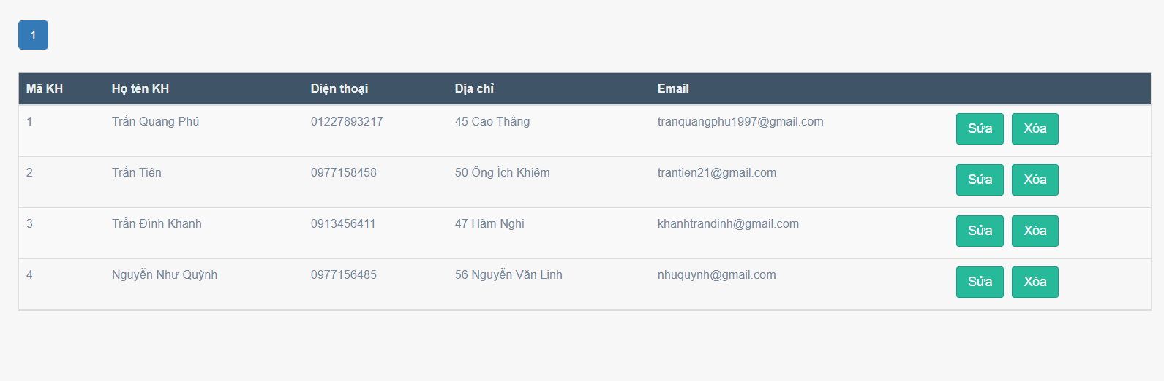

Figure 5.19. Customer Management Page

**2.8. Comment Management Page**

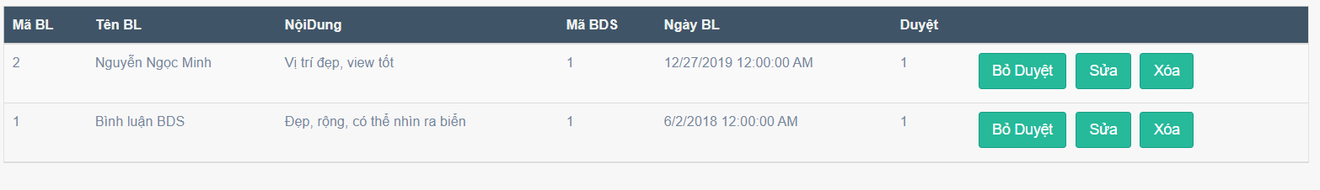

Figure 5.20. Comment Management Page

**2.9. Renting Management Page**

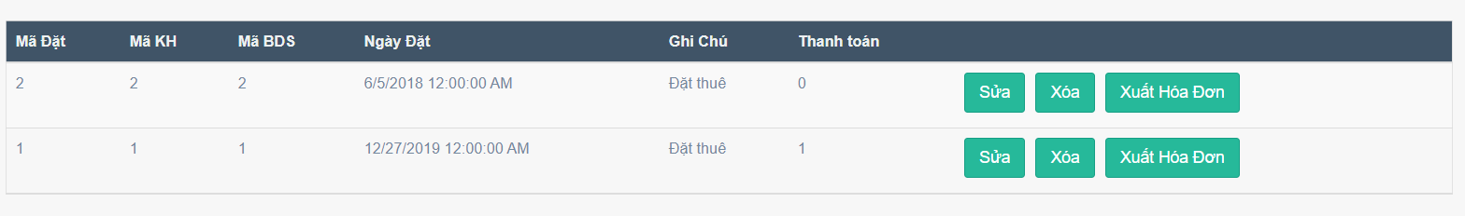

Figure 5.21. Renting Management Page

**2.10. Invoice Management Page**

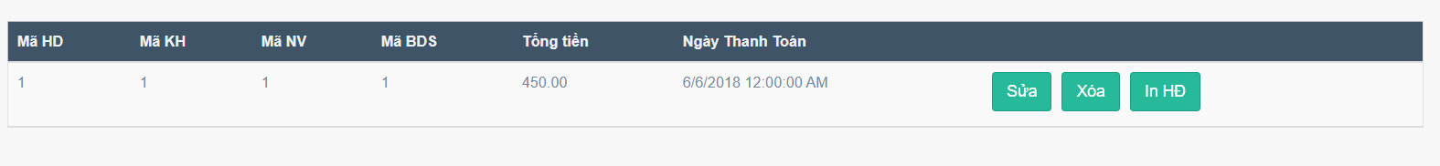

Figure 5.22. Invoice Management Page

**2.11. Invoice’s info Checking Page**

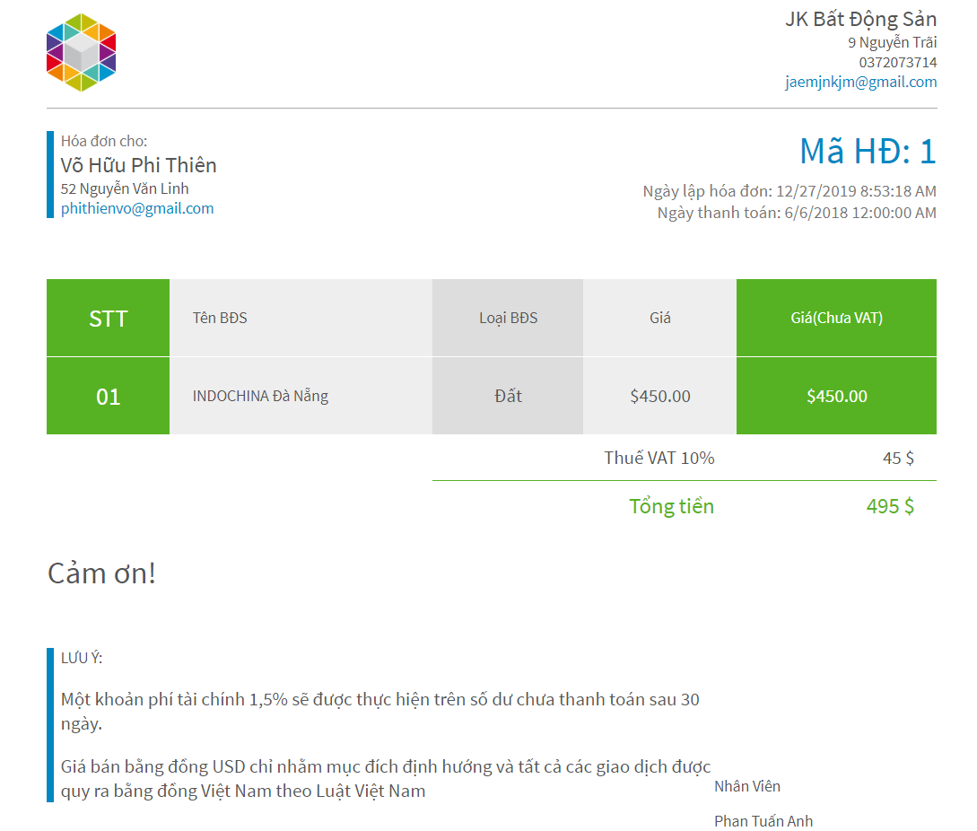

Figure 5.23 Invoice’s checking info Page

**CHAPTER VI: CONCLUSION**

**1.Evaluate**

The topics you have built are highly applicable. With the requirements of the project, I tried and did:

Building a website illustrating the leasing, buying and selling online, allowing users to post information on real estate leasing or selling.

Support users searching for real estate according to their needs by posting many real estate details on the web with pictures of real estate clearly.

Giving users real estate price information in some areas of Central Vietnam

However, because the subject related to the type of real estate, I have not been able to go to the field, only researching through the Internet and some information from relatives so the sketching functions have not been completed. Next is the analysis phase, the design you have not taken advantage of the power of the support tool UML, so the approach is modest and difficult. So there are still some things that exist:

The system still has many inadequacies such as not optimized in database structure, code, interface and some other functions.

There is no inventory of properties sold or rented through the website.

The automatic removal of properties from the site has not yet been implemented when the contract with the company expires.

The system does not support the updated features of real estate exchange rates.

Not via card payment yet.

**2. Development**

Continued development and overcoming of disadvantages:

Building a system with more functions such as automatic mail notification when the contract is about to expire, allowing administrators and customers to communicate directly on the website, notify customers when there is any movable property in accordance with their requirements.

Information on real estate rates depending on the region and location

The user interface is more user friendly, optimizing the system to make the website work faster, improving the functions and security of the system.